FILTER FUNCTIONALITY

1 . We need to make filters (Industry) dynamic.

2. UI of the filters.

Images taken from Jobong.com

EXPECTED FILTER UI:

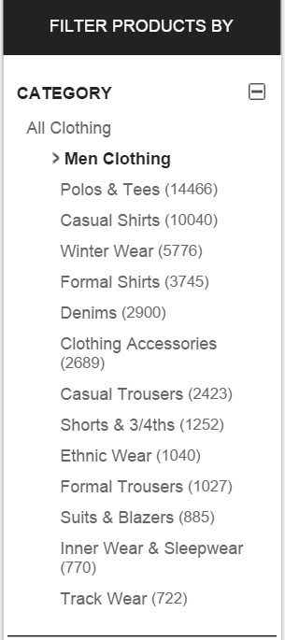

We need borders and separators in the filters as shown above also with a heading.

We will have a show more link for industries as shown below.:

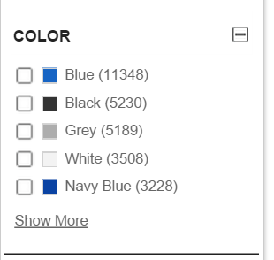

On clicking on show more , a modal will be displayed having all the industries as shown below:

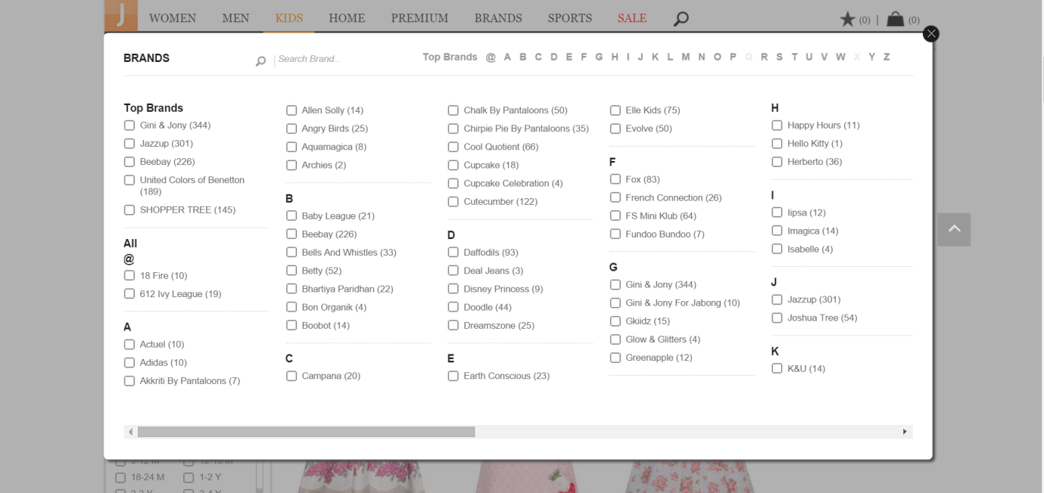

After the user selects the required industries, then the industries selected can be shown on the landing page as shown below :

